# Account Types and Functions

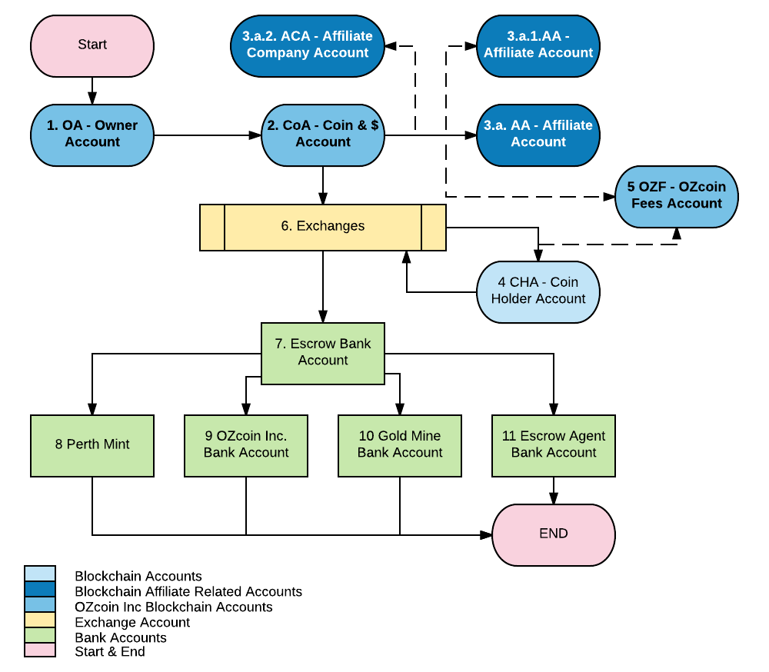

# Account Type

There are 3 different types of accounts in the system:

1. Blockchain accounts
2. An exchange account and
3. Bank accounts

## A Blockchain Accounts

The blockchain accounts consist of

1. OA Owner Account - This account will not hold any ether besides the required transaction ether. It will also not hold any OZcoins. The following admin functions will be administered from this account and only this account:
   1. Assigning new roles to accounts
   2. Minting new uOZcoins
   3. Freezing and unfreezing accounts
   4. Managing arbitration
2. CoA Coin Account –
   1. All newly minted OZcoins will be minted to this account. It therefore serves as the main distribution account.
   2. It will also hold all ether that is paid for any ether purchases from the Owner Account.
   3. All OZcoin transfers will be made from this account for initial Exchange purchases and
   4. All transfers for purchases via direct debit from the Escrow bank account
3. AA - Affiliate Accounts – There are two types of affiliate accounts
   1. 3.a.2. ACA - Affiliate Company Account. This is an account role that is granted by the Administrator on request and once an affiliate principal agreement has been put in place. This account
      1. Sends out affiliate links through which anyone can open an OZcoin Gold Affiliate wallet. The link automatically sets the Affiliate Company as the wallets Affiliate Company.
      2. The link from this account also sets the Affiliate Company as the Affiliate that’s linked to the wallet.
      3. Receives commission for every sale throughout its affiliate network.
      4. Receives commission from every wallet that has been directly opened from its link.
      5. The account holder can buy OZcoins through this account wallet.
      6. The account holder can sell OZcoins through this account wallet.
      7. The account holder can transfer OZcoins through this account wallet
      8. The account holder can transfer Ether through this account wallet
   2. 3.a.1. AA - Affiliate Accounts can only be generated when a wallet is opened through another affiliate account’s link and will be linked to that affiliate and the main Affiliate Company account through the wallet. You can do the following from this account.
      1. Sends out affiliate links through which anyone can open an OZcoin Gold Affiliate wallet. The link automatically sets the main Affiliate Company as the new wallets Affiliate Company.
      2. The Affiliate from which this link was sent is set as the Affiliate in the new wallet.
      3. Receives commission from every wallet that has been directly opened from its link.
      4. The account holder can buy OZcoins through this account wallet.
      5. The account holder can sell OZcoins through this account wallet.
      6. The account holder can transfer OZcoins through this account wallet
      7. The account holder can transfer Ether through this account wallet
   3. 3.b CHA- Coin Holder Account. These are the common account that a normal coin owner will open. Through this account an owner can
      1. Store OZcoins
      2. Transfer OZcoins
      3. Store Ether
      4. Transfer Ether
   4. 3.c OZF – OZcoin Zee Account. This is a normal Coin Holder Account to which all OZcoinGOld transaction fees are automatically transferred to. This account can
      1. Receive OZcoins – All OZcoin transaction fees are paid into this account
      2. Transfer OZcoins
      3. Transfer Ether.

## Exchange Accounts

The OZcoin Coin account will be linked to an exchange through which all OZcoins will be liquidated. This exchange(s) account is linked to the Escrow bank account. This way funds can be cleared form the exchanges without anyone having the ability to move funds in any other way but that which is stipulated in the agreement.

OZcoin Inc may have several exchange trading accounts in order to liquidate ether. It may also have several Exchange floating accounts through which OZcoin-Gold can be floated on exchanges. These accounts will all be linked to the OZcoinGold Escrow account.

## OZcoinGold Escrow Account

The escrow account is a bank account through which aal OZcoiGold sales will be liquidated. From her the escrow agent along with another two signatures, distribute the received funds according to the agreement.

## Bank Accounts

### Perth Mint

The escrow agent deposits one third of the sales proceeds after cost to the Perth Mint to purchase gold certificates. These will be published on the blockchain

### OZcoin Inc.

The escrow agent deposits OZcoin Inc’s 2% commission of the gross sales price into this bank account.

### Gold Corp Account

The escrow agent deposits two thirds of all the sales proceeds less the cost of sale, affiliate commissions, OZcoin Inc. commission and Escrow Agent costs to the Gold Corp bank account.

### Escrow Agent Account

The escrow agent transfers their fees to this account.

# Required Accounts

1. OZCoin Inc Source Account (Contract owner and Administrator) – Account to which all OZcoins are minted and from which all initial OZcoins are being sold.
2. Mine Sales Income Account (Managed by OZcoin Inc.) All Sales Ether is received and kept in this account.
3. OZcoin Commission Account. All initial sales commissions is paid / transferred to this account.
4. OZcoin Transaction Fee Account. All automated transaction fees are automatically allocated to this account in uOZC
5. Auditors Account. To enable the upload of the Auditors report to the block chain
6. Escrow Agent Account. To allow the upload of the Gold Certificates to the BC
7. Affiliate Account. Coin Owner accounts that will also receive the Affiliate commission from purchases through linked wallets.
8. Affiliate Company Account. Coin Owner accounts that will also receive the Affiliate Company commission from purchases through linked wallets.
9. Coin Owner Account. Hold all coin owner OZC and ether.

# Sales or Transfer Relationships.

## OZcoin Source Account

All initial sales from here

* To Coin Holder accounts –
* To affiliate Accounts

Coin Holders

* To Coin Holders
* To affiliates

Affiliates

* To Affiliates
* To Coin Holders

Exchanges

* To Coin Holders